Contents
When first saving the new document based on this template, Do REFERENCES > ! Update Table > Update Entire Table, to update this section's initial contents.
(Don't attempt to modify the rest of this section manually.)
2 Introduction 1
3 Nomadland Scares Me To Death 1
4 Appendixes 1
4.1 [My husband] "Bo never knew his parents…" https://www.youtube.com/watch?v=thCJ26iWNDg 1
4.2 "There's no final goodbye…" https://www.youtube.com/watch?v=NfZLJVaQ-PU 1
4.3 "I'll see you down the road." 1
4.4 Fern Smiles 1
4.5 Useful Items 1
4.5.1 Big Dot 1
4.5.2 Major Divider 1

Introduction
This page constitutes commentary, based on Fair Use, on a thought-provoking and insightful document.
You are encouraged to see the document in its original context unless you are interested in this Commentary Markup by Frederick N. Chase.
The markup is almost always made via
i) emphasis (yellow highlight, red, bold, underline, or font size),
ii) [pink bracketed commentary],
iii) hypertext linking of a term or statement to a web page believed to offer quick uncontroversial augmentation and
iv) omission (elision) of material – indicated by a series of dots somewhat proportional to the amount of original material elided.
This page is part of the homeplace web portal. Homeplace is advertisement-free and not for profit.

Nomadland Scares Me To Death
And it should scare you, too.
Bev Potter

Feb 27, 2021
·4 min read
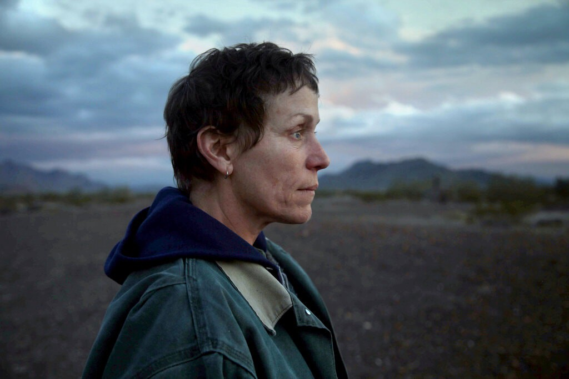
Frances McDormand in Chloé Zhao’s film “Nomadland” (Joshua Richards/Searchlight Pictures)
Let me just get this out of the way: I love Frances McDormand.
Ever since Fargo changed our world view about pregnant cops and wood chippers, I have fangirled over her chin dimple and her IDGAF attitude. She is that rarest of things: a truly talented actor who is both the character she plays and yet deeply herself.
In Nomadland, the quasi-documentary about America’s transient labor force, McDormand’s performance is beautifully spare and naturalistic. She’s aging before our eyes like (gasp!) a normal human being instead of a Hollywood star. Her eyebrows remain permanently arched in surprise at all she sees.
I want to be Frances McDormand.
And I have to admit, I’m more than a little obsessed with RV life. I read all of the rah-rah “Isn’t RV life GREAT?” articles. I follow the glossy Instagram accounts and try to imagine living in a room on wheels. What would it be like to live in my second-grade school bus that had gum under the seats and windows that would either never open or never close?
So much freedom! So much self-congratulation at leaving a smaller footprint on Mother Earth! So many flimsy sundresses while my perfect family and I frolic in a golden meadow!
The world depicted in Nomadland is completely different. Nobody on Instagram is talking about the pros and cons of pooping into a 2-gallon bucket versus a 5-gallon bucket. None of the articles talk about the complete lack of safety nets or access to basic services.
And all the while, Amazon spews forth agitprop about its CamperForce to drown out the rumbles of discontent issuing from within its cavernous warehouses, which Nomadland completely ignores. (For more about that, go read What Nomadland Gets Wrong About Gig Labor by Wilfred Chan.)
It was easy to distance myself from the very real people inhabiting Nomadland until I heard an older woman (i.e. older than me, but not by a lot) tell McDormand’s character, Fern, that she only receives $500 per month from Social Security.
This prompted me to look up my own future projected Social Security earnings, which, in the best of all possible worlds, will come to a little less than $1200 per month, or $14,400 per year. And that’s if I’m lucky.
My dad worked for Ford. As a UAW member, he had job security, full health insurance coverage for life, and a pension.
I have zilch, zero, nada. No benefits, no health insurance, and no retirement. To call Nomadland a wake-up call is putting it mildly. It’s more like a slap in the face.
One reviewer on IMDb found the movie unrealistic because Frances McDormand’s net worth is $30 million. Okay, well, it is a movie, and at least one person in it had to know how to act. This isn’t a John Waters film.
More cogently, another reviewer took issue with the movie’s avoidance of hard topics like the prevalence of mental illness and drug use among “nomads”, although it’s safe to say that McDormand’s character clearly has, at the very least, some emotional issues to contend with.
It’s important to remember that Nomadland the film is based on the 2017 book Nomadland: Surviving America in the Twenty-First Century by journalist Jessica Bruder, and that a lot got left on the cutting room floor. Although I struggle to understand exactly why that is.
Would the movie have suffered from the truth? Would fewer people have wanted to see it if the female “nomads” expressed more fear of violent crime and sexual assault? Surely things aren’t as glowingly Kumbaya as Zhao portrays them in a loose-knit community where women live alone in trucks, vans, and in at least one instance, a Prius.
Even calling them “nomads” lends a completely misleading air of adventure to the way these desperate people survive.
In fact, the more I think about it, the angrier I get.
- What a wasted opportunity to explore the failures of capitalism and the utter disregard with which America views its senior population.
- What a missed chance to talk about Amazon’s predation of the old and destitute so that Jeff Bezos can fly to Mars.
Nomadland is a pretty film, reminiscent of Terrence Malick in the way the camera lingers on scenes of natural beauty. But even that is a subversion of the direness of Fern’s situation. “Sure, she lives in a van, but look at the view!”
What greater conversations could Nomadland have started if it wasn’t so in love with the scenery and had the guts to take on Amazon? Much like the lives of the people inhabiting it, in the end, Nomadland is a disappointment.
Sign up for Popping Off

Appendixes

[My husband] "Bo never knew his parents…" https://www.youtube.com/watch?v=thCJ26iWNDg

"There's no final goodbye…" https://www.youtube.com/watch?v=NfZLJVaQ-PU

"I'll see you down the road."

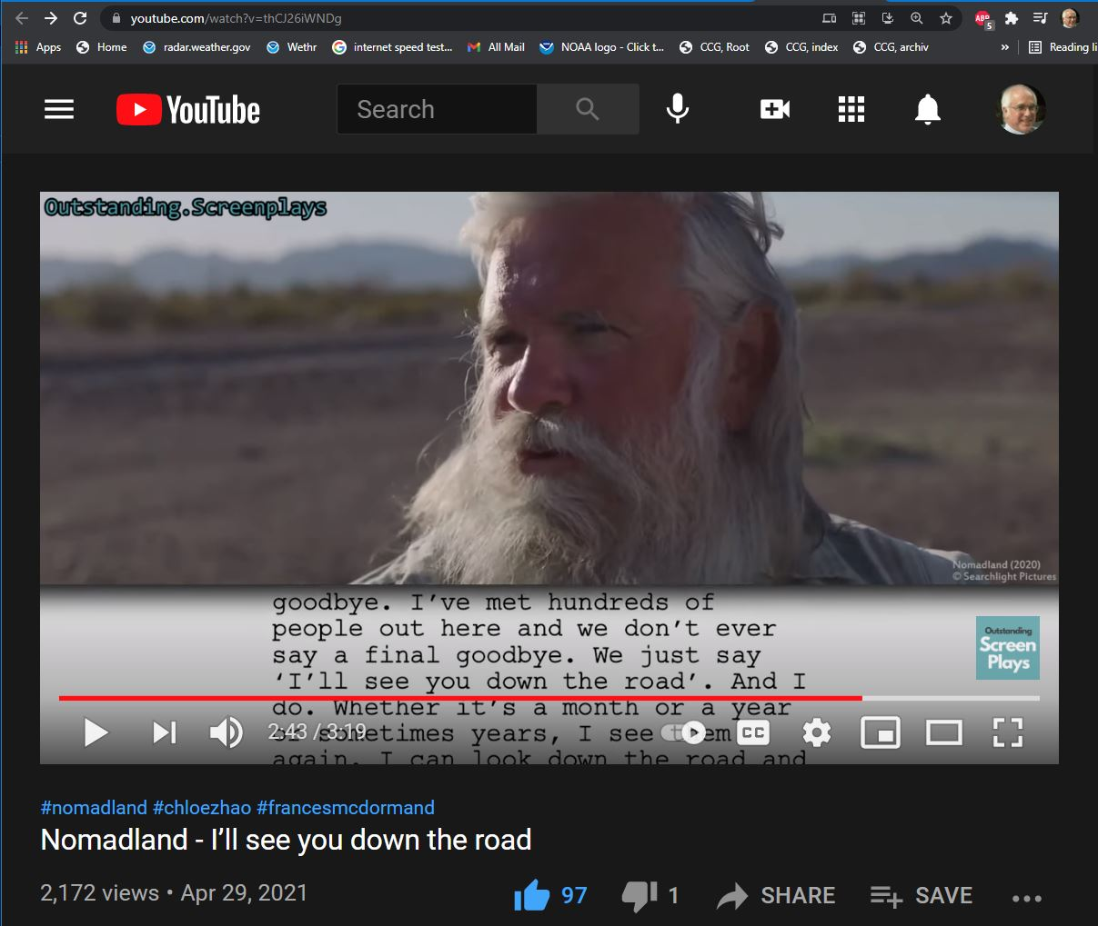
We just say 'I'll see you down the road'. And I do.

Fern Smiles
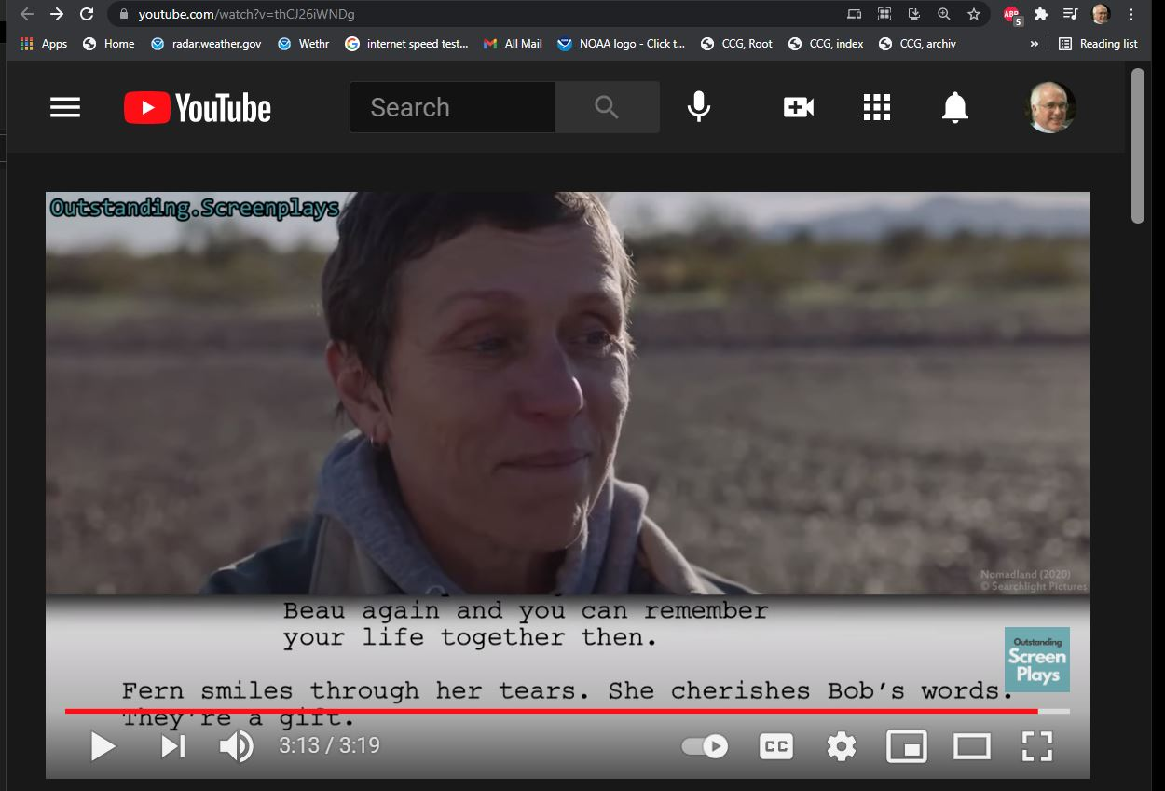
Fern smiles.

Useful Items

Big Dot
•

Major Divider
Above

Below

